**FSPM Assignment # 2**

**HASSAN ALI**

**K20-1052 BSE-7B**

**Functional Points**

* **External Inputs:** Admin login inputs, admin registration input, customer registration, payment information, employee registration, employee login, product detail, customer history. **(Count: 8)**
* **External Outputs:** Notification messages, status response, reports for sales or customer history. **(Count: 3)**
* **External Inquiries:** Product availability check, customer history, employee records. **(Count: 3)**
* **Internal Logical Files:**  System configuration file, user account data, product data, booking records, payment records, Employee data. **(Count: 6)**
* **External Interface Files:** Database for records, third party payment system(assuming), external storage for backups. **(Count: 3)**

**Weighting Factors**

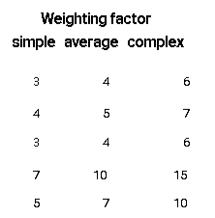

Assuming average for External input and external output, simple for External Inquiries and Internal logical files and complex for External Interface files

**Total count = (8*4)+ (3*5)+(3*3)+(6*7)+(3*10) = 123**

## Complexity Adjustment Values

Calculating value adjustment factor based on 14 below points.

1- Reliable backup and Recovery: 3

2- Communication Required: 3

3- Distributed processing functions: 2

4- Performance Critical? : 4

5- System run in heavily utilized OS environment?: 2

6- On-line data entry: 3

7- Input transactions over multiple operations/screens: 3

8- Master files updated online: 3

9- Complex input, output, files, inquiries: 2

10- Internal processing complex: 2

11- Code reusability: 3

12- Conversion and installation included in design: 3

13- Multiple installations in different organizations: 2

14- Facilitate change and ease of use: 3

**Total sum for VAF = 35**

## Computation of Functional Points

Weighted Functional Points= Count Total for FP * (0.65 + 0.01 * (Value Adjustment Factor))

Weighted FP= 123 * (0.65 + 0.01 * (35))

**Functional Points = 123**

**Estimation of Lines of Code**

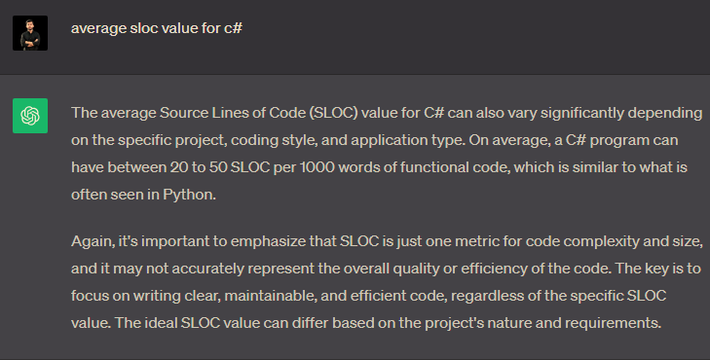

Therefore taking Avg SLOC as 35 (70/2)

Lines of code= Weighted FP * Avg SLOC

LOC = 123 * 35 = 4305

LOC = 4.305 KLoc

## Intermediate COCOMO

Effort (E) = a x (Size)^bx C

Where a=2.4 and b=1.05, C is cost drivers.

Size=kLoc

**So E=2.4 x (3.51)^1.05 x C**

### Cost Drivers.

* RELY (Required Software Reliability): Since the software is intended to automate important operations in an electronic market, it should be fairly reliable. Let's assume it is "Nominal" (e.g., 1.00).
* DATA (Database Size): Given that the software will be handling bookings, product management, customer interactions, and more, we can assume that it will handle a considerable amount of data. Let's assume it is "High" (e.g., 1.14).
* CPLX (Product Complexity): The system includes a variety of features including login, registration, payment processing, booking, and more, which suggests it is complex. Let's assume it is "High" (e.g., 1.17).
* TIME (Execution Time Constraint): There's no specific information in the SRS or Project Charter about execution time constraints. Let's assume it is "Nominal" (e.g., 1.00).
* STOR (Main Storage Constraint): Similar to TIME, there's no specific information about storage constraints. Let's assume it is "Nominal" (e.g., 1.00).
* VIRT (Virtual Machine Volatility): There's no specific information about virtual machine volatility. Let's assume it is "Nominal" (e.g., 1.00).
* TURN (Computer Turnaround Time): No specific information about computer turnaround time is available. Let's assume it is "Nominal" (e.g., 1.00).
* ACAP (Analyst Capability): The SRS is well-documented, which suggests a skilled analyst team. Let's assume it is "High" (e.g., 1.19).
* AEXP (Applications Experience): The team is developing an Electronic Management System, which is somewhat specialized. Let's assume it is "Nominal" (e.g., 1.00).
* PCAP (Programmer Capability): The SRS does not provide enough information to determine this, but we'll assume the team is skilled. Let's assume it is "High" (e.g., 1.17).
* VEXP (Virtual Machine Experience): There's no information about virtual machine experience. Let's assume it is "Nominal" (e.g., 1.00).
* LEXP (Programming Language Experience): The system will be developed using C#, a well-known language. Let's assume it is "High" (e.g., 1.09).
* MODP (Modern Programming Practices): The SRS does not provide enough information to determine this. Let's assume it is "Nominal" (e.g., 1.00).
* TOOL (Use of Software Tools): There's no information about the use of software tools. Let's assume it is "Nominal" (e.g., 1.00).
* SCED (Required Development Schedule): The project has specific milestones with target dates, which indicates some schedule pressure. Let's assume it is "Nominal" (e.g., 1.00).

**EAF = RELY * DATA * CPLX * TIME * STOR * VIRT * TURN * ACAP * AEXP * PCAP * VEXP * LEXP * MODP * TOOL * SCED = 1.00 * 1.14 * 1.17 * 1.00 * 1.00 * 1.00 * 1.00 * 1.19 * 1.00 * 1.17 * 1.00 * 1.09 * 1.00 * 1.00 * 1.00 = 1.32**

**Final Calculations**

So E=2.4 x (4.305)^1.05 x 1.32

**E= 9.6 staff-months**

So **10 staff-months rounded up**

The **development time** expected is:

2.5x( E )^0.38

2.5 x (9.6)^ 0.38 => 5.9 => **6 months.**

**Average staff members** required:

**Effort/Tdev so 9.6/5.9 => 1.62 so 2** staff-member developer required.

Productivity required from the staff person is:

Size/Effort so 4305/9.6 => 448.4 so 450 lines of code per staff-month.

**Average Salary for C# developer = 75000**

**Cost = Effort x Average Salary = 9.6 * 75000 = 720000 PKR**

## Results

|  |  |
| --- | --- |
| **Average lines of code expected** | **4.305 KLoc** |
| **Effort in staff-months** | **9.6 staff-months** |
| **Time of development** | **6 months** |
| **Developers Required** | **2 developer required** |
| **Productivity expected** | **450 Lines of code per staff-month** |
| **Cost Associated** | **720,000 PKR** |